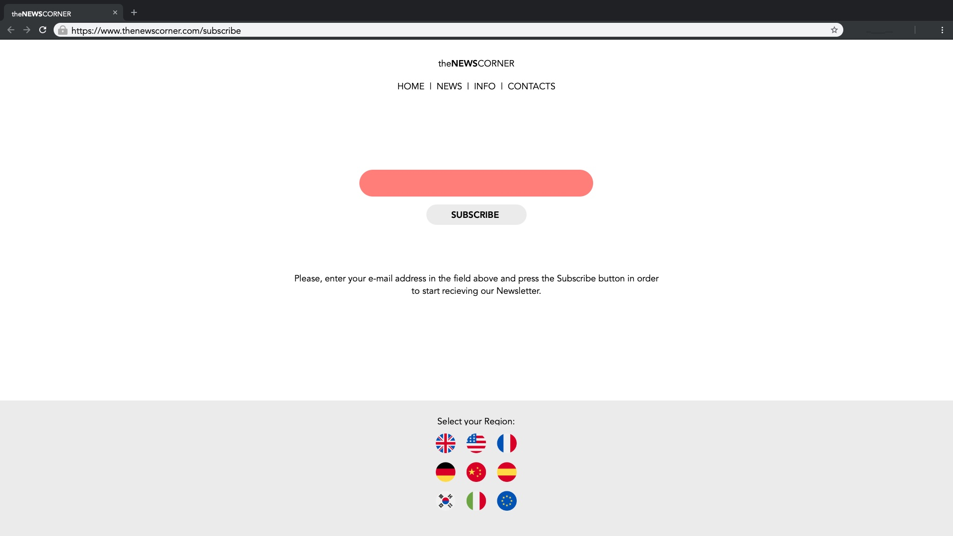

Please write down, what will you test on the web page shown above in order to confirm if it’s ready or not to be published online:

Name:

Date:

Test scenario: